Renju lesson on January 3, 2002

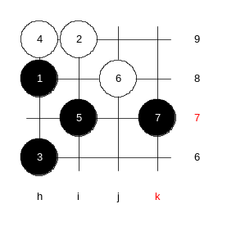
Hello everyone! Welcome to Online Renju Class. Happy News Year to all of you!
We continue with i10. What do we know about this position? What did we learn about 8-j6?

We learned that black must use positional style in one of the variants there and the black win is not clear.

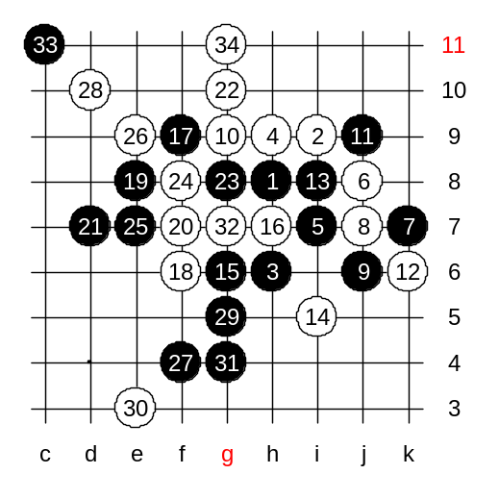
Today we will take a look at another 8th move. That is? Yes, j7. Black has two 9th move here – j6, j9. I remember, people used to play j6 more often than j9. Move 9-j6 was the most common move until the day Nakamura came out with a strong development after 9–j9. Before that, 9-j9 was considered to be equal to 9-j6 or even weaker. We will first check 9-j6. White next moves are obvious, please tell me. Actually, 9-j6 is pretty dangerous, too. White moves are all so natural, like a ship drifting in water.
We introduce aggressive playstyle now. White plays 18-f6 – it was suggested my majority of the class. Actually, black is strong indeed, but white should be able to defend. Black must continue aggressive plan, because positional style does not work now. Black attack is about to fail. Black can win only when white makes a mistake. If white is calm and correct, black fails. Well, now black has jammed.
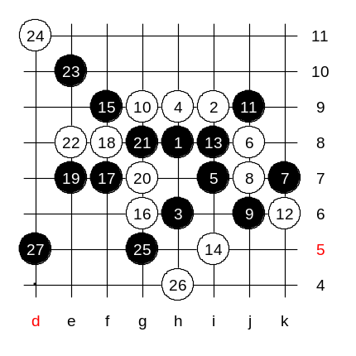

Let’s check careful style instead of aggressive style. Move 15-f9 is the strongest. Black gives up the g6 point and focuses on positional round style. Black can get very safe position here. Very strong. Black likely wins.

Actually, move 18 was not so strong. Lets look.
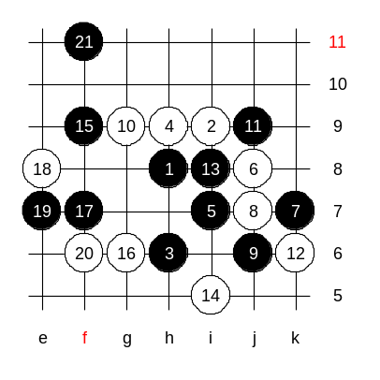
This 18-e8 is the best. Now white can defend. White’s 20-f6 is good, too. And now, black has only upper side left to do something. If white is correct all the time then black doesn’t win I believe. Black will try to stretch lines to upper space but it is not easy. I suggest we end the variant here because time is up. You see what’s happening. Black has an advantage and attack, but winning is not easy. However, black is safe enough here to not lose game at any times.

